OBJECTIVES ___Chapter 5: Section 5.6, The Law of Cosines (Pages 435 – 440).
- Know that an oblique triangle is a triangle that does not contain a right angle.
- Understand The Triangle Inequality Theorem: The sum of the lengths of any two sides of a triangle must be greater than the third side.
- Use the Law of Cosines to solve a right triangle or an oblique triangle when given SAS or SSS.
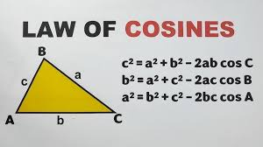
- Be able to find the areas of both right and oblique triangles.
- Use Area = 0.5(base)(height) for right triangles and oblique triangles when you know the base and the height.
- Use The Law of Sines Area Formula for oblique triangles when you know 2 sides and an included angle (SAS).
- Use Hero’s (Heron’s) Formula when you know all 3 sides (SSS).
- Use the Law of Sines when you know AAS, ASA, and SSA (the Ambiguous Case..
- 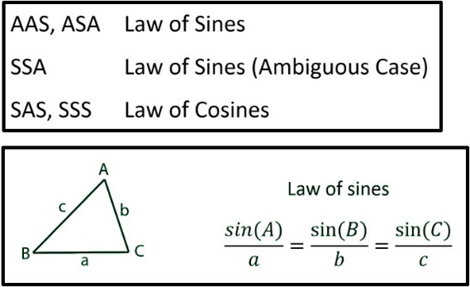
MONDAY (3.31.25)
Do you have any questions about the work assigned previously?
- Pages 440 and 441, Exercises, #5, 7, 17, 21. Also, Exercises, #2, 4, 6, 8, 10, 18, 22, 23. Round to the nearest tenth.
Review for a Quiz (The Law of Cosines, Hero’s Law, The Law of Sines Area Formula) to be taken on Thursday. You may use one page of notes.
WEDNESDAY (4.2.25)
Discuss the Law of Sines. See pages 427-431.
Class Work: Page 432, #2, 10, 16.
Quiz (The Law of Cosines, Hero’s Law, The Law of Sines Area Formula). You may use one page of notes.
Class Work/Homework: Page 432, #1, 3, 11, 13.

FRIDAY (4.4.25)
Discuss the work assigned previously: Page 432, #1, 3, 11, 13.
Class Work/Homework: Pages 432, 433, #37, 39, 43, 44.

SATURDAY (4.5.25)________ E-LEARNING
E-Learning work: Illustrate each of these problems and show your work. Round to the nearest tenth. Pages 441 and 442, #29, 30, 35, 38.

